**Random Forest Regression**

* Random Forest is a popular machine learning algorithm that belongs to the supervised learning technique. It can be used for both Classification and Regression problems in ML. It is based on the concept of ensemble learning, which is a process of combining multiple classifiers to solve a complex problem and to improve the performance of the model.
* Random Forest is a classifier that contains a number of decision trees on various subsets of the given dataset and takes the average to improve the predictive accuracy of that dataset.

**How does Random Forest algorithm work?**

Random Forest works in two-phase first is to create the random forest by combining N decision tree, and second is to make predictions for each tree created in the first phase.

The Working process can be explained in the below steps and diagram:

**Step-1:** Select random K data points from the training set.

**Step-2:** Build the decision trees associated with the selected data points (Subsets).

**Step-3:** Choose the number N for decision trees that you want to build.

**Step-4:** Repeat Step 1 & 2.

**Step-5:** For new data points, find the predictions of each decision tree, and assign the new data points to the category that wins the majority votes.

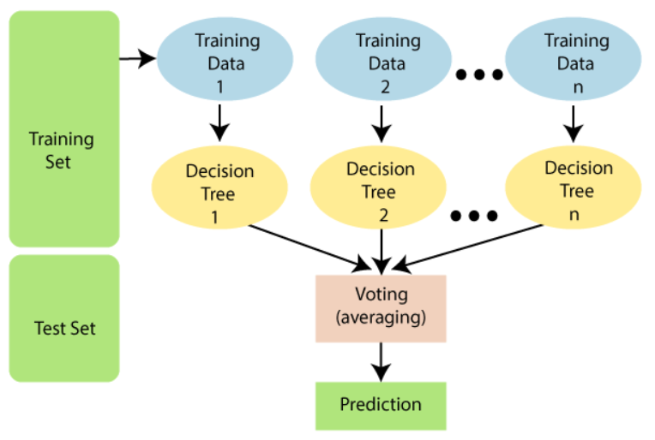

Example --

